# Home Loan Application Low Level Design (LLD)

**Current Document Version: [*1.0*]**

**Date: 15/02/2022**

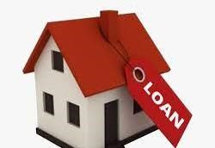

**Presented by:**

**Shital Wadile**

|  |  |  |  |  |
| --- | --- | --- | --- | --- |
| **Name** | **Department** | **Role** | **Signature** | **Date** |
|  |  |  |  |  |
|  |  |  |  |  |
|  |  |  |  |  |

# Approvers of this document

* **DOCUMENT CHANGE HISTORY**

|  |  |  |  |
| --- | --- | --- | --- |
| **Document Version#** | **Author** | **Date** | **Description** |
| **1.0** |  | **15/02/2022** |  |
|  |  |  |  |
|  |  |  |  |

**Content**

*1.0 Document Purpose ........................................................................................... 5*

*2.0 Intended Audience ........................................................................................... 5*

*3.0 Project Background, Objective(s) ...................................................................... 6*

3.1 Project Background ...........................................................................................6

3.2 Project Objective ...............................................................................................6

*4.0 Design Pattern .................................................................................................. 8*

*5.0 UML Diagram .....................................................................................................9*

*5.1 Use case Diagram ...............................................................................................9*

*5.2 Sequence Diagram.............................................................................................. 10*

*5.2.1 Customer Sequence Diagram …………………………………………………………………………10*

*5.2.2 Admin sequence diagram ……………………………………………………………………………….11*

*5..3 Activity Diagram…………………………………………………………………………………………….12*

6.0 Database Diagram……………………………………………………………………………………………13

## 1.0 Document Purpose

This document describes the solution architecture for Home Loan application. Applying for home loan is a hectic and long process . Hence we have created online home loan application which will make the loan process easy and user friendly.

## 2.0 Intended Audience

This document is intended as a reference for the following roles and stakeholders who are interested in the Home Loan Application technical architecture. The people who wants to apply for home loan are always welcome to our home loan application.

**Role**

**Product Owners/SME**

**Business Analysts**

**Enterprise Architects**

**Solution Architects**

**Developers**

**3.0 Project Background, Objective(s)**

# 3.1 Project Background

Home Loan Application leads to perform management of loan appliers details where one can register themselves and apply for home loan efficiently. I t makes the hectic loan process efficient.

# 3.2 Project Objective

The main purpose behind developing this home loan application is to make the whole loan process trouble-free. Our customers can apply for home loan through our application in virtual manner.

Because of this, The whole process of home loan becomes easy and user-friendly.

# Problems

The processing takes more than 10-12 days depending on the profile of the customer and the documents submitted

Requires individual to visit the financial institution and fill out necessary forms

Risk of losing crucial paperwork is higher

# Solution

The processing happens in the next hours and involves instant approvals

Can be done from anywhere and at the click of a button

Completely secure process

4.0

|  |  |  |
| --- | --- | --- |
| **Design Pattern** | **Name** | **Description** |
| 1 | Backend | Web API and Asp .Net Core |
| 2 | Frontend | Angular |
| 3 | Database | SSMS |

## Use case Diagram

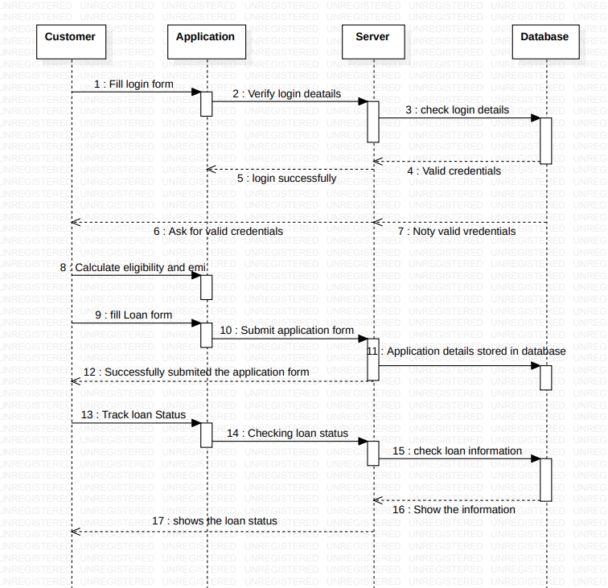**Customer Sequence Diagram**

10

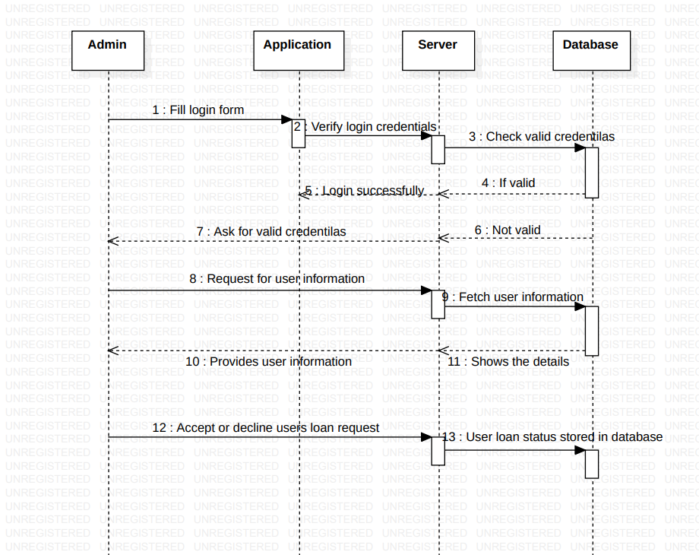**Admin Sequence Diagram**

**Activity Diagram**

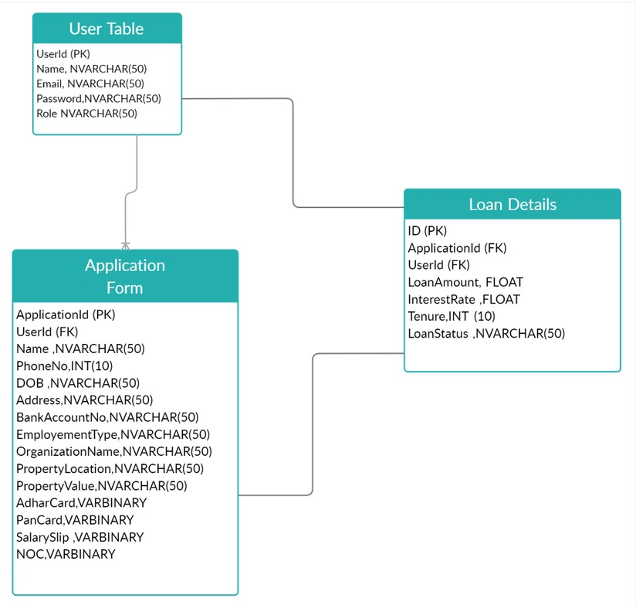**Database Diagram**

2

**Thank you!!!!**